

**DEDAN KIMATHI UNIVERSITY OF TECHNOLOGY.**

**PROJECT PROPOSAL ON**

**ORGAN DONOR-DOCTOR-RECIPIENT SYSTEM**

**BY**

**JEPCHIRCHIR HILDA**

**REG NO: C027-01-0595/2013**

**A project submitted to the department of information technology in the school of computer science and information technology in partial fulfillment of the requirements for the award of the degree of Bachelor of Science in Business Information Technology at Dedan Kimathi University of Technology.**

**2016.**

# DECLARATION

This proposal is my original work and has not been presented for a degree in any other university.

…………………. …………………

Signature Date

JEPCHIRCHIR HILDA

C027-01-0595/2013

This proposal has been submitted for examination with my approval as university supervisor.

………………… …………………

Signature Date

KENNEDY SENAGI

# ABSTRACT

Organ donation is the [donation](https://en.wikipedia.org/wiki/Donation) of [biological tissue](https://en.wikipedia.org/wiki/Tissue_%28biology%29) or an [organ](https://en.wikipedia.org/wiki/Organ_%28anatomy%29) of the [human body](https://en.wikipedia.org/wiki/Human_body) from a living or dead person to a living recipient whose tissues or organs have become irreversibly dysfunctional. [Transplantable organs and tissues](https://en.wikipedia.org/wiki/Transplantable_organs_and_tissues) include; blood, kidneys, heart, bones, tendons and the skin. They are removed in a [surgical procedure](https://en.wikipedia.org/wiki/Surgery) following a determination, based on the donor's medical and social history, of which are suitable for transplantation. Such procedures are termed [allotransplantations](https://en.wikipedia.org/wiki/Allotransplantation), distinguish them from [xenotransplantation](https://en.wikipedia.org/wiki/Xenotransplantation), the transfer of animal organs into human bodies. As of June 21, 2013, there are 118,617 people waiting for life-saving organ transplants in the U.S. Of these, 96,645 await kidney transplants. While views of organ donation are positive there is a large gap between the numbers of registered donors compared to those willing to donate organs on a global level.

This is mainly because potential donors lack the knowledge they require as most of them come from developing countries such as Kenya. A system that can be remotely accessed is therefore required to enable such individuals save a life. Furthermore, organ donations in the past have been faced with major challenges such as how to make payments and whom the payments will be made to. Many recipients in the developed countries take advantage of their donors’ lack of knowledge pertaining their rights in terms of payment for the human materials donated. An efficient portal will therefore provide a module whereby recipients will prepay a donor just before a surgery is performed.

Table of Contents

DECLARATION 2

ABSTRACT 3

LIST OF TABLES 6

DEFINITION OF TERMS 6

CHAPTER ONE 7

INTRODUCTION 7

1.1 Background 7

1.2 Statement of the problem 8

1.3 Objectives 8

1.3.1 Main objective 8

1.3.2 Specific objectives 9

1.4 Research questions 9

1.5 Justification 9

1.6 Scope 10

CHAPTER TWO 10

LITERATURE REVIEW 10

2.1 Introduction 10

Mugenda and Mugenda (1999) states that review of literature involves systematic identification, location and analysis of existing documents containing information related to the research problem being studied. They further go on to argue that literature review helps the researcher to have detailed knowledge of what has been done so as to avoid unnecessary and detailed duplication, demonstrate his/her familiarity with existing body of knowledge, increase the researcher’s confidence in the researcher’s professional ability as well as form the framework through which the research findings are to be interpreted. 10

2.2 Case studies 12

2.2.1 Case study 1; Organ donation taskforce 12

2.2.2 Case study 2; Human organ donation system in India. 12

2.2.3 Case study 3; Dying for organs: a case for transplants. 13

2.3 Summary 13

2.4 Research Gap 14

2.5 Proposed methodology 14

CHAPTER THREE 15

METHODOLOGY 15

3.0 DATA COLLECTION METHODS 15

3.1 Software design 16

Advantages of the waterfall approach 17

Disadvantages of the waterfall approach 17

3.2 Pilot test 18

3.3 Preliminary data processing and analysis 19

PROJECT GENERAL IMPACT. 20

SCHEDULE 21

Table 1 21

BUDGET 21

Table 2 21

CHAPTER FOUR 22

4.1 Analysis 22

4.1.2 Requirement analysis 22

4.1.3 System analysis 22

4.1.3.1 FLOWCHART 23

**4.1.3.2 USECASE DIAGRAM** 25

4.1.3.4 DATA FLOW DIAGRAM 27

REFERENCES 29

APPENDIX 29

# LIST OF TABLES

Table 1……………………………………………………………………………………Schedule

Table 2……………………………………………………………………………………Budget

# DEFINITION OF TERMS

Allotransplantation – Removal of human organs in a [surgical procedure](https://en.wikipedia.org/wiki/Surgery) following a determination, based on the donor's medical and social history, of which are suitable for transplantation

Xenotransplantation - Transfer of animal organs into human bodies.

Cadaveric- a situation where donation is carried out from a dead person’s body.

# CHAPTER ONE

# INTRODUCTION

## 1.1 Background

Organ donation is the [donation](https://en.wikipedia.org/wiki/Donation) of [biological tissue](https://en.wikipedia.org/wiki/Tissue_%28biology%29) or an [organ](https://en.wikipedia.org/wiki/Organ_%28anatomy%29) of the [human body](https://en.wikipedia.org/wiki/Human_body) from a living or dead person to a living recipient in need of a transplant. [Transplantable organs and tissues](https://en.wikipedia.org/wiki/Transplantable_organs_and_tissues) are removed in a [surgical procedure](https://en.wikipedia.org/wiki/Surgery) following a determination, based on the donor's medical and social history, of which are suitable for transplantation.

While views of organ donation are positive there is a large gap between the numbers of registered donors compared to those awaiting organ donations on a global level. With advent of the internet and the proliferation of web users, patient doctor consultations are even done online which reduces both time and resource wastage for doctors and patients hence increasing profitability for both. A similar system for donor recipient consultation is required for cases where a patient who requires an organ transplant cannot access a potential donor. The recipient will be able to search from a list of potential donors and choose which donor meets their own specifications in terms of blood group, age, medical history and circumstances of death.

## 1.2 Statement of the problem

Organ transplantation has become a viable treatment for an increasing number of patients suffering from irreversible organ failure. In response to the steeply rising demand for transplantation, both the number of transplant centers and the number of patients on waiting lists have grown rapidly. Because organ donation has not kept pace with demand, each year a greater number of patients die while awaiting organ donors thus the need for a system that will at least help reduce the number of deaths caused by a delay in transplantation.

The current doctor patient portal needs to add a segment where patients in need of organ transplants can interact with their potential donors. The system will be web based, up to date and also can be assessed remotely by donors and recipients. The recipients should be able to interact with the donors from wherever they are without any difficulty. The current systems have several cases of system flow hence this system should be efficient such that there is no system flow and several users can access the system at the same time. The current systems are also kind of complex hence need for this new system which will be a bit simpler for its users.

## 1.3 Objectives

This is a list of the main goals that this system aims at achieving;

### 1.3.1 Main objective

The main objective of the system is to provide efficiency. This system will be user friendly as well as cost friendly.

### 

### 1.3.2 Specific objectives

The other objectives of the system are:

1. To link donors to recipients.
2. To reduce cost of operation by recipients as they can easily access donors.
3. To enable people interested in having organ or tissue transplants to have such information at the palm of their hands electronically.
4. To allow for an automated donor recipient handling through an online interface.
5. To help reduce deaths caused by lack of functional body organs or tissues by patients waiting for treatment due to the time taken by doctors to undertake tests on potential donors as finding a matching donor will be fast.

### 1.4 Research questions

1. How efficient are the current channels of communication between donors, recipients and doctors?
2. Do people use internet information on issues regarding their health?
3. To what extent will the final product impact the health sector as far as donors and recipients are concerned?
4. Will the proposed service be available to everybody or just a particular group of people?

## 1.5 Justification

After fully implementing this proposed system, patients who require organ transplants will be able to access potential donors’ information from the internet and consult with their donors from anywhere hence will cut on the cost of unnecessary travelling in the case where the affected patients are miles away from their donors and doctors as they will just have to inquire from their mobile phones or computers.

The system will also enable recipients to make their payments directly to the donors thus they will not have to make queues with other patients at the billing offices in order to pay for the services rendered to them at the hospital.

## 1.6 Scope

Efficient donor recipient portal will be a web based system that will support every aspect of the donation process. This includes admin log in, user log in/registration, medical history, doctor search, automatic cost calculation, booking cancellation, email on appointment booking, feedback, organ donor registration and organ donor search based on type of organ.

# CHAPTER TWO

# LITERATURE REVIEW

## 2.1 Introduction

## Mugenda and Mugenda (1999) states that review of literature involves systematic identification, location and analysis of existing documents containing information related to the research problem being studied. They further go on to argue that literature review helps the researcher to have detailed knowledge of what has been done so as to avoid unnecessary and detailed duplication, demonstrate his/her familiarity with existing body of knowledge, increase the researcher’s confidence in the researcher’s professional ability as well as form the framework through which the research findings are to be interpreted.

Organ donation is the [donation](https://en.wikipedia.org/wiki/Donation) of [biological tissue](https://en.wikipedia.org/wiki/Tissue_%28biology%29) or an [organ](https://en.wikipedia.org/wiki/Organ_%28anatomy%29) of the [human body](https://en.wikipedia.org/wiki/Human_body) from a living or dead person to a living recipient in need of a [transplantation](https://en.wikipedia.org/wiki/Organ_transplantation). [Transplantable organs and tissues](https://en.wikipedia.org/wiki/Transplantable_organs_and_tissues) are removed in a [surgical procedure](https://en.wikipedia.org/wiki/Surgery) following a determination, based on the donor's medical and social history, of which are suitable for transplantation.

A donor is any person alive or dead from whom a blood tissue or organ is taken for transfusion, implantation or transplant. For a person to be considered a dead donor he or she must be declared dead for removal of body tissues or organs to be removed. A recipient on the other hand is a person whom the donation of any form of human material is made to in a case where his or her own body organs have become irreversibly nonfunctional.

In this chapter I give some of the literature I reviewed. What I outline here is what I actually consider useful. I reviewed various literatures but I could not include all of it in this chapter as it could make it voluminous.

## 2.2 Case studies

### 2.2.1 Case study 1; Organ donation taskforce

There are not enough donated organs to save people’s lives in the UK. Although over 3,000 people in the UK received an organ transplant in 2014/15, another 1,000 died after having waited in vain on the waiting list, which currently numbers over 8,000 people. This figure does not reflect the true extent of need; many who could have their lives transformed by a transplant never even reach the waiting list. Need is at minimum 50% more than is currently available. it is a desperate situation.

The organ donation Taskforce was established in 2006 and asked to identify obstacles to organ donation and suggest ways of overcoming them. In its report organs for transplants, published in January 2008, the Taskforce made 14 recommendations. It was persuaded that if these were fully implemented, a 50% increase in donations could be delivered within five years. All the recommendations were accepted by UK health ministers. The recommendations are currently in the process of implementation across the UK in a program that is being led by Sir Bruce Keogh, medical director of the National Health Service in England, and overseen by the program delivery Board.

Some countries such as Spain and increasingly the USA – have high rates of organ donation. This success has not been achieved by changing one single aspect of their organ donor system in isolation, but rather by addressing each piece in the complex jigsaw of interdependent elements that make up a successful donation program.

### 2.2.2 Case study 2; Human organ donation system in India.

The Indian Society of Organ Transplantation was established in 1987 with a goal to provide a common forum to all involved in the transplant activity. The society initiated from CMC Vellore and its inaugural meeting was held at Institute of Kidney Disease and Research Centre, Civil Hospital, Ahmedabad in 1988. The society has over 650 members which include clinicians, basic scientists and others involved in the field of transplantation.

The most notable developments in this area were Jean Boral’s discovery of immunosuppressive drugs called cyclosporine in the mid-1970s. This drug was approved for commercial use (in the U.S.) in 1983. Unfortunately, the need for organ transplants continues to exceed the organ supply. Fifteen people die each day (or one person dies every 1 hours and 45 minutes) due to the shortage of transplantable organ; and every 18 minutes a new name is added to the transplants waiting list. But as medical technology improves, and more donors become available, thousands of people each year will live longer and better lives.

### 2.2.3 Case study 3; Dying for organs: a case for transplants.

Verah Okeyo’s article on the Sunday nation 28th February 2015

If Dr. Anthony Were had a kidney bank, he could save patients who seek dialysis services at Kenyatta national hospital a lot of money and pain. He says one source of organs could be Kenyans who consent to donate their kidneys and other organs when they die –a donation termed cadaveric but it is forbidden by Kenyan law.

He told the Sunday Nation: ’There are athletic people who do not suffer from major infections and when they die they are buried with healthy lungs, liver, kidney, bones, eyes and intestines which could save many lives”. The shortage of body organs remains a global challenge, one that could be solved through encouraging healthy people to pledge to donate their organs once they are dead. Dr. Were lists the cost incurred by patients who have not found a donor and rely on weekly dialysis to survive. “Dialysis at Kenyatta costs sh.5,000 and may be conducted twice a week. After that, there are drugs to be bought to control the patient’s blood pressure, anemia and other side effects of dialysis.”

The costs in private hospital are higher “A transplant costs about sh.300,000. The patient heals in about a month.” Says Dr. Were. He further says that he has met Kenyans who are willing to donate their organs upon death, but they are unaware of how to go about it thus need for a system that will make it easy for them offer their organs for donation.

## 2.3 Summary

The above reviews all aim at providing a platform where potential donors can give up their organs for donation to save lives be it globally, internationally or locally. The system will be user friendly thus will be able to be accessed from the remote places where people are willing to donate but lack the information on how to go about it.

## 2.4 Research Gap

Despite the existing systems on organ transplantation, research shows that there is a large and troubling gap between the number of people who could be organ donors and the number who actually donate. This valuable and informative report demonstrates that;

* Most organ donors are not recognized or identified by any health care professionals in hospitals. The reports acknowledge limitations to the data on donation potential which is based on estimates.
* Donation services vary significantly across the country. Whether a potential donor becomes an organ donor depends to a great degree on the area within the hospital in which he or she receives care. This will change since the system will be available to give the users the information they require.

2.5 Proposed methodology

As for each case of study, there is always a suitable method of implementation of the case under study. This will answer two main questions; how was the data collected and how was it analyzed. A quantitative method will be used for this research problem. Collection of data will be by use of personal observations, interviews and questionnaires.

To undertake all the above methods of data collection, sampling will be used to select a sample population. The sampling will either be random or selective. This will reduce the amount of data to be analyzed and at the same time the data will be more accurate.

# CHAPTER THREE

# METHODOLOGY

According to Donald and Delno (2006), research methodology involves the description of methods applied in carrying out a research study. A good research methodology yields high quality data.

Mugenda and Mugenda (1999) states that this section describes the procedures that have been followed in conducting the study. At this stage we will develop the techniques of obtaining data that we will collect to test hypothesis, if any.

### 3.0 DATA COLLECTION METHODS

To collect primary data I’ll use the following methods of data collection:

* Questionnaires

I’ll create both structured and unstructured questionnaires and randomly distribute them to various doctors and patients so I can get their opinion.

* Interviews

This is a research method in which the researcher indulges in a conversation and uses a list of questions to question a respondent and record his or her answers.

I will have an oral one on one conversation with the doctors and patients so as to get their feedback on what they think about my proposed system.

To collect secondary data I’ll obtain the information I require from:

* Journals

I’ll collect important data from books and magazines written under the same title from either the same or different authors.

* The internet

I’ll search for various sites in the internet under the same title.

## 3.1 Software design

In this particular project, I shall use the waterfall approach as my development methodology. It’s a linear approach to software development which distinctly shows and completes each individual stage before moving to the next. These stages include;

* Analysis.

During this phase research is conducted which includes brainstorming about the system, what is going to be and what purpose it is going to fulfill. At this stage, all possible requirements of the system to be developed are captured. Requirements are a set of functions and constraints that the end user expects from the system. The requirements are gathered from the end user at the start of the software development phase. The requirements are analyzed for their validity and the possibility of incorporating the requirements in the system to be developed is also studied. Finally a requirement specification document is created which serves the purpose of guideline for the next phase of the model

* Design.

This is formulating the design of the system on paper. The functions of each of the parts are decided and the engineering units are placed. Before starting the actual coding phase, it is highly important to understand the requirements of the end user and have an idea of how the end product should look like.

* Development.

Here the source code of the system is written

* Implementation

Here the whole design and its construction are put under a test to check its functionality. If there are any errors then they will surface at this point of the process

* Testing and QA.

Each unit that has been developed is tested for its functionality; this is referred to as unit testing. Unit testing mainly verifies if the units meet their specifications.

* Release and maintenance.

The system is delivered to the client who is in my case the patients. Their feedbacks are taken and any changes if required are made. Not all the problems come into picture directly but may arise from time to time and needs to be solved.

### Advantages of the waterfall approach

* Planning is made easier since each stage of the software design process is assigned a deadline.
* Progress is more easily measured as the full scope of the work is known in advance.
* The software design is completed in the early development process. This approach lends itself to projects where multiple software components must be designed for integration with external systems.
* The software can be designed completely and more carefully based on a complete understanding of the software deliverables.

### Disadvantages of the waterfall approach

* Gathering and documenting user requirements is difficult.
* There is a possibility that the user will be dissatisfied with the final product.

## 3.2 Pilot test

This is a short term or small scale experimental trials that will help me learn how a large scale project might work in practice. My studies will be based on the following feasibilities;

Operational feasibility

The growing demand in organ requirements requires that urgent measures be taken to counter this consistent issue in our country. It was therefore in my best interest that I decided to develop a system to alleviate this predicament. I believe my output in the form of a web based application will be acceptable to the government and society as it will adhere to government regulations.

Technical feasibility

The implementation and use of my proposed project will be easily achievable due to the recent increase in the use of the internet. More people are able to access this service due to increase in the use of mobile devices and widespread cellular reception in the country.

Economic feasibility

There might be some resource constraints in the implementation of my proposed project but with proper resource allocation and management, the available resources may work just fine in implementing this system.

Schedule

The 26 weeks provided by my school for research, coding and implementation will be enough to come up with a proper output with the help of my supervisor.

Pilot testing on my system will be carried out upon completion of the coding process and will be done in three stages;

1. Code and unit testing
2. System testing
3. User acceptance testing.

## 3.3 Preliminary data processing and analysis

Data collected during system testing will enable me to identify defects on my system after which I will find out solutions on the same and making sure I have evaluated all the data before proceeding to my next steps. On analysis, I’ll identify how much data I’ll use, identify which complexity of models I’ll use, what tools to use and make an estimation of the processing time. User requirement will also be crucial in in developing a better version of the system if in any case the user will not be satisfied with the initial version.

# PROJECT GENERAL IMPACT.

The system will help reduce the time taken for a patient in need of an organ transplant to undergo a surgery and receive an organ or tissue he or she is in need of. This in turn increases chances of survival as a recipient has to only search for an existing donor whose information is already laid out in the system rather than looking for a doctor to perform tests on a potential donor which can be frustrating as some of the willing donors may not have exactly matching specifications to those of the recipients.

This system will also provide a portal where recipients will directly make prepayments to the donors thus reducing the rate at which poor illiterate donors whose main aim of donating their human materials is to pay off debts are being manipulated by doctors and even recipients from the mighty states.

# SCHEDULE

|  |  |  |  |  |  |  |  |  |
| --- | --- | --- | --- | --- | --- | --- | --- | --- |
| Month  Task | May | June | July | August | Sept | Oct | Nov | Dec |
| Research |  |  |  |  |  |  |  |  |
| Proposal writing |  |  |  |  |  |  |  |  |
| Submission |  |  |  |  |  |  |  |  |
| Analysis |  |  |  |  |  |  |  |  |
| Design |  |  |  |  |  |  |  |  |
| Coding |  |  |  |  |  |  |  |  |
| Implementation |  |  |  |  |  |  |  |  |
| Documentation |  |  |  |  |  |  |  |  |
| Presentation |  |  |  |  |  |  |  |  |

### Table 1

# BUDGET

For the system to be complete the following expenditure will have to be incurred;

|  |  |
| --- | --- |
| Item | Cost (in kshs) |
| Laptop | 40,000 |
| Printer | 3,000 |
| Printing materials | 500 |
| Internet access | 3,000 |
| HP flash disk | 1,000 |
| Total amount | 47,500 |

### Table 2

# CHAPTER FOUR

## 4.1 Analysis

This is a broad subtopic that is further divided into requirement analysis and system analysis to gain a better understanding of the system.

### 4.1.2 Requirement analysis

It encompasses those tasks that go into determining the needs or conditions to meet a new project, taking account of the possibly conflicting [requirements](https://en.wikipedia.org/wiki/Requirement) of the various [stakeholders](https://en.wikipedia.org/wiki/Stakeholder_%28corporate%29), analyzing, documenting, validating and managing the system requirements. (chung & Brian, 2002)

##### **Functional requirements**

1. The system should enable recipients view the available organs using their mobile phone or computers.
2. The system should manage donors, doctors and recipients.
3. The system should allow doctors add willing donors to the system.

##### **Non-functional requirements**

1. The system should be easy to maintain.
2. The system should be reliable in that it offers user support.
3. The system should provide security to the database by use of passwords
4. System should be flexible to expansion in future.

### 4.1.3 System analysis

This is a problem solving technique that decomposes the system into its various component pieces for the purpose of the studying how well those component parts work and interact to accomplish their purpose..

## 4.1.3.1 FLOWCHART

Flowchart is a visual representation of the sequence of steps and decisions needed to perform a process. Each step in the sequence is noted within a diagram shape. Steps are linked by connecting lines and directional arrows. This allows anyone to view the flowchart and logically follow the process form beginning to the end.

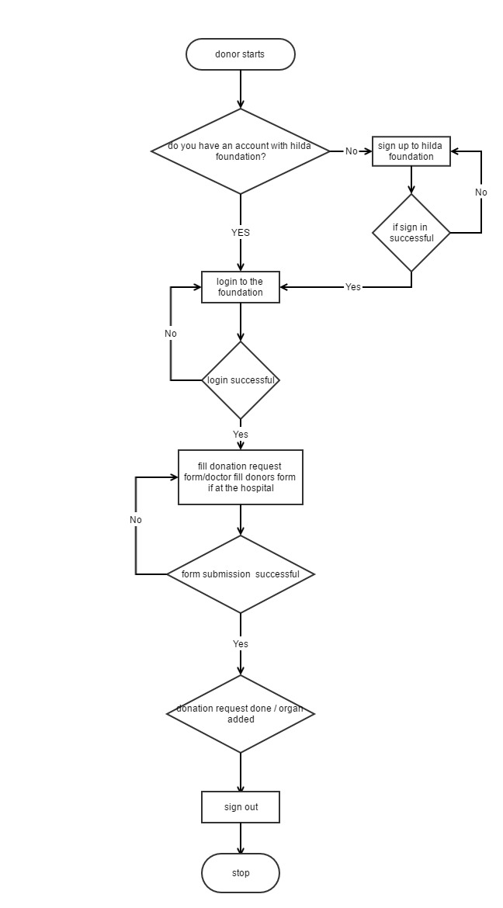

**4.1.3.2 USECASE DIAGRAM**

**Use Case Diagram**

This is a set of scenarios that describes an interaction between a user and the system. It displayed the relationship among actors and use cases.

The two main symbols are:

It represented an android user who interacted with the system being modeled. In this project, the actor is the student.

This is an external view of the system that represented some actions the user performed to complete a task. The use case in this project are actions performed by the recipient of viewing available organs.

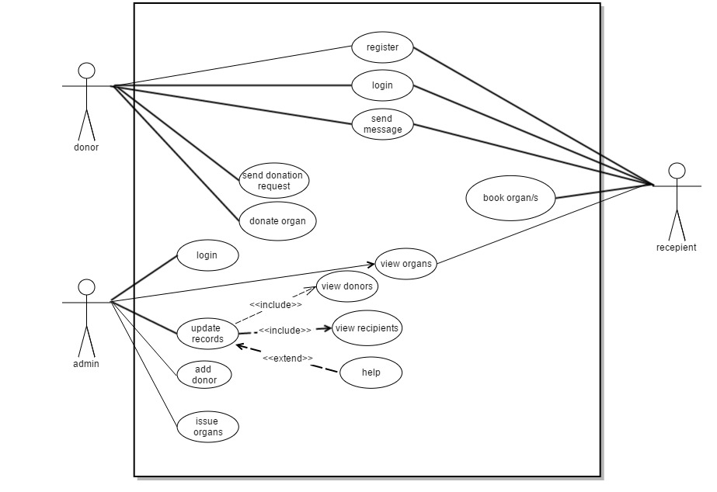

## 4.1.3.4 DATA FLOW DIAGRAM

DFD explains how data flows through the system under and how the data is processed by the system.

#### LEVEL 0 DFD

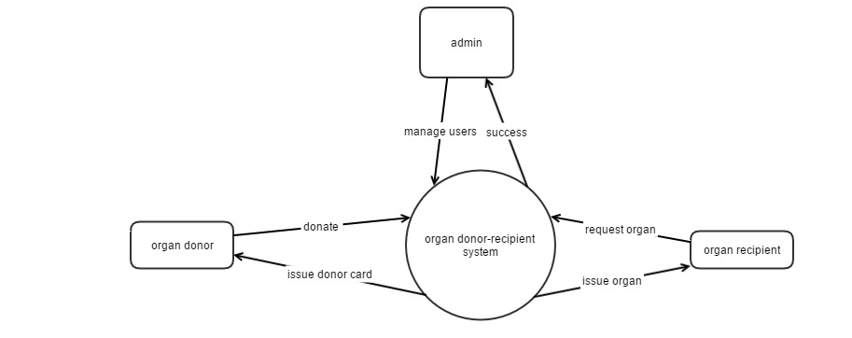

#### LEVEL 1 DFD

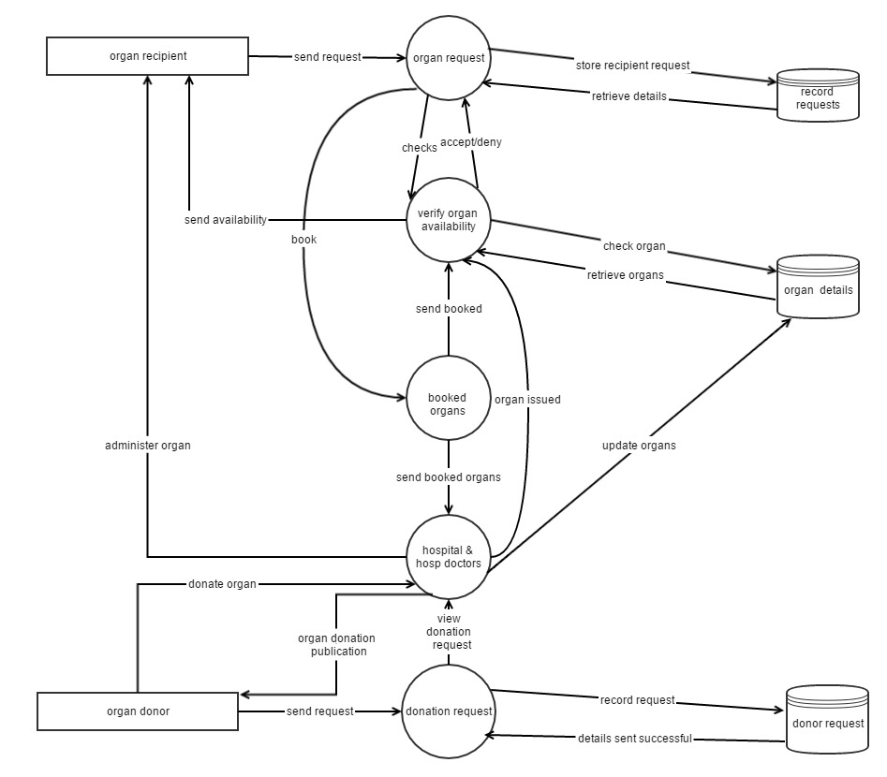

# REFERENCES

1. The potential impact of an opt out system for organ donation in the UK.

An independent report from the organ donation task force.

1. The global organ shortage; economic causes, human consequences and policy responses.

By T. Randolph Beard; David L. Kaserman; Rigmar Osterkamp.

1. <https://www.innovativepublication.com/admin/upload/IJPCA_3(1)_25-42.pdf>
2. <http://www.mohanfoundation.org/organ-donation-transplant-resources/organ-allocation-model-india-who-gets-organ.asp>

# APPENDIX

On 30th November 2016 changes are coming to the organ transplantation sector. A new web-based system will be deployed for connecting recipients to donors